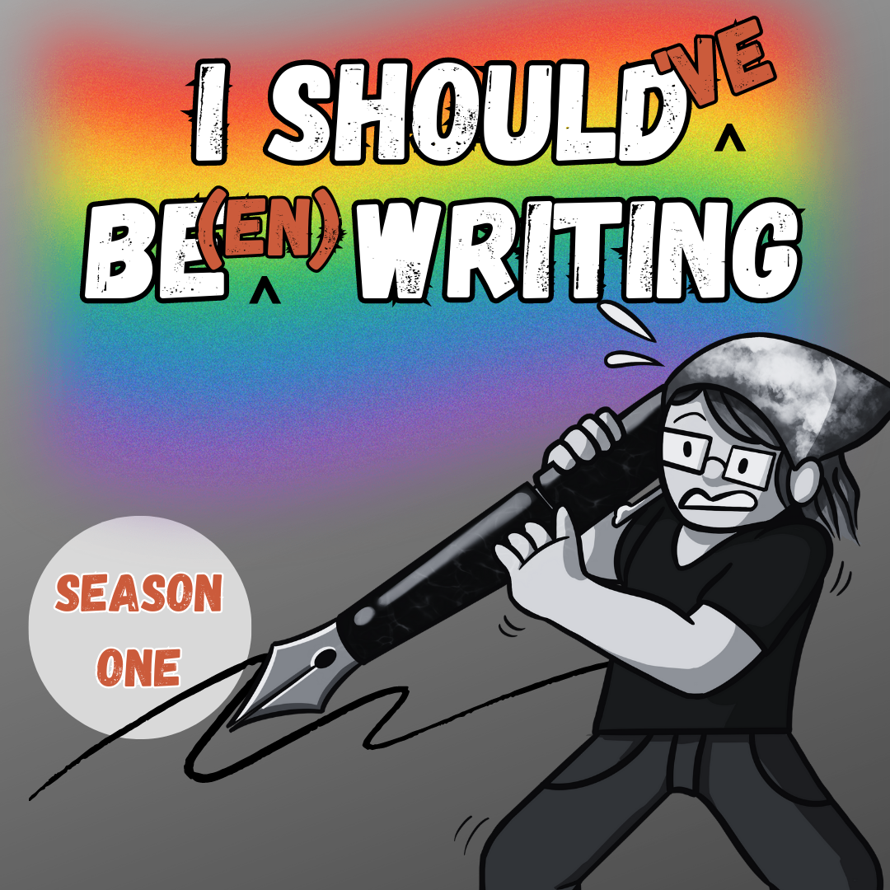
Submission Guidelines
I Should’ve Been Writing S1 Ep3
SUMMARY KEYWORDS
submission guidelines, market, ralan, instructions, rejection, paying
SPEAKERS
Mur Lafferty
Get the annotated transcript when you support via Patreon or Substack!
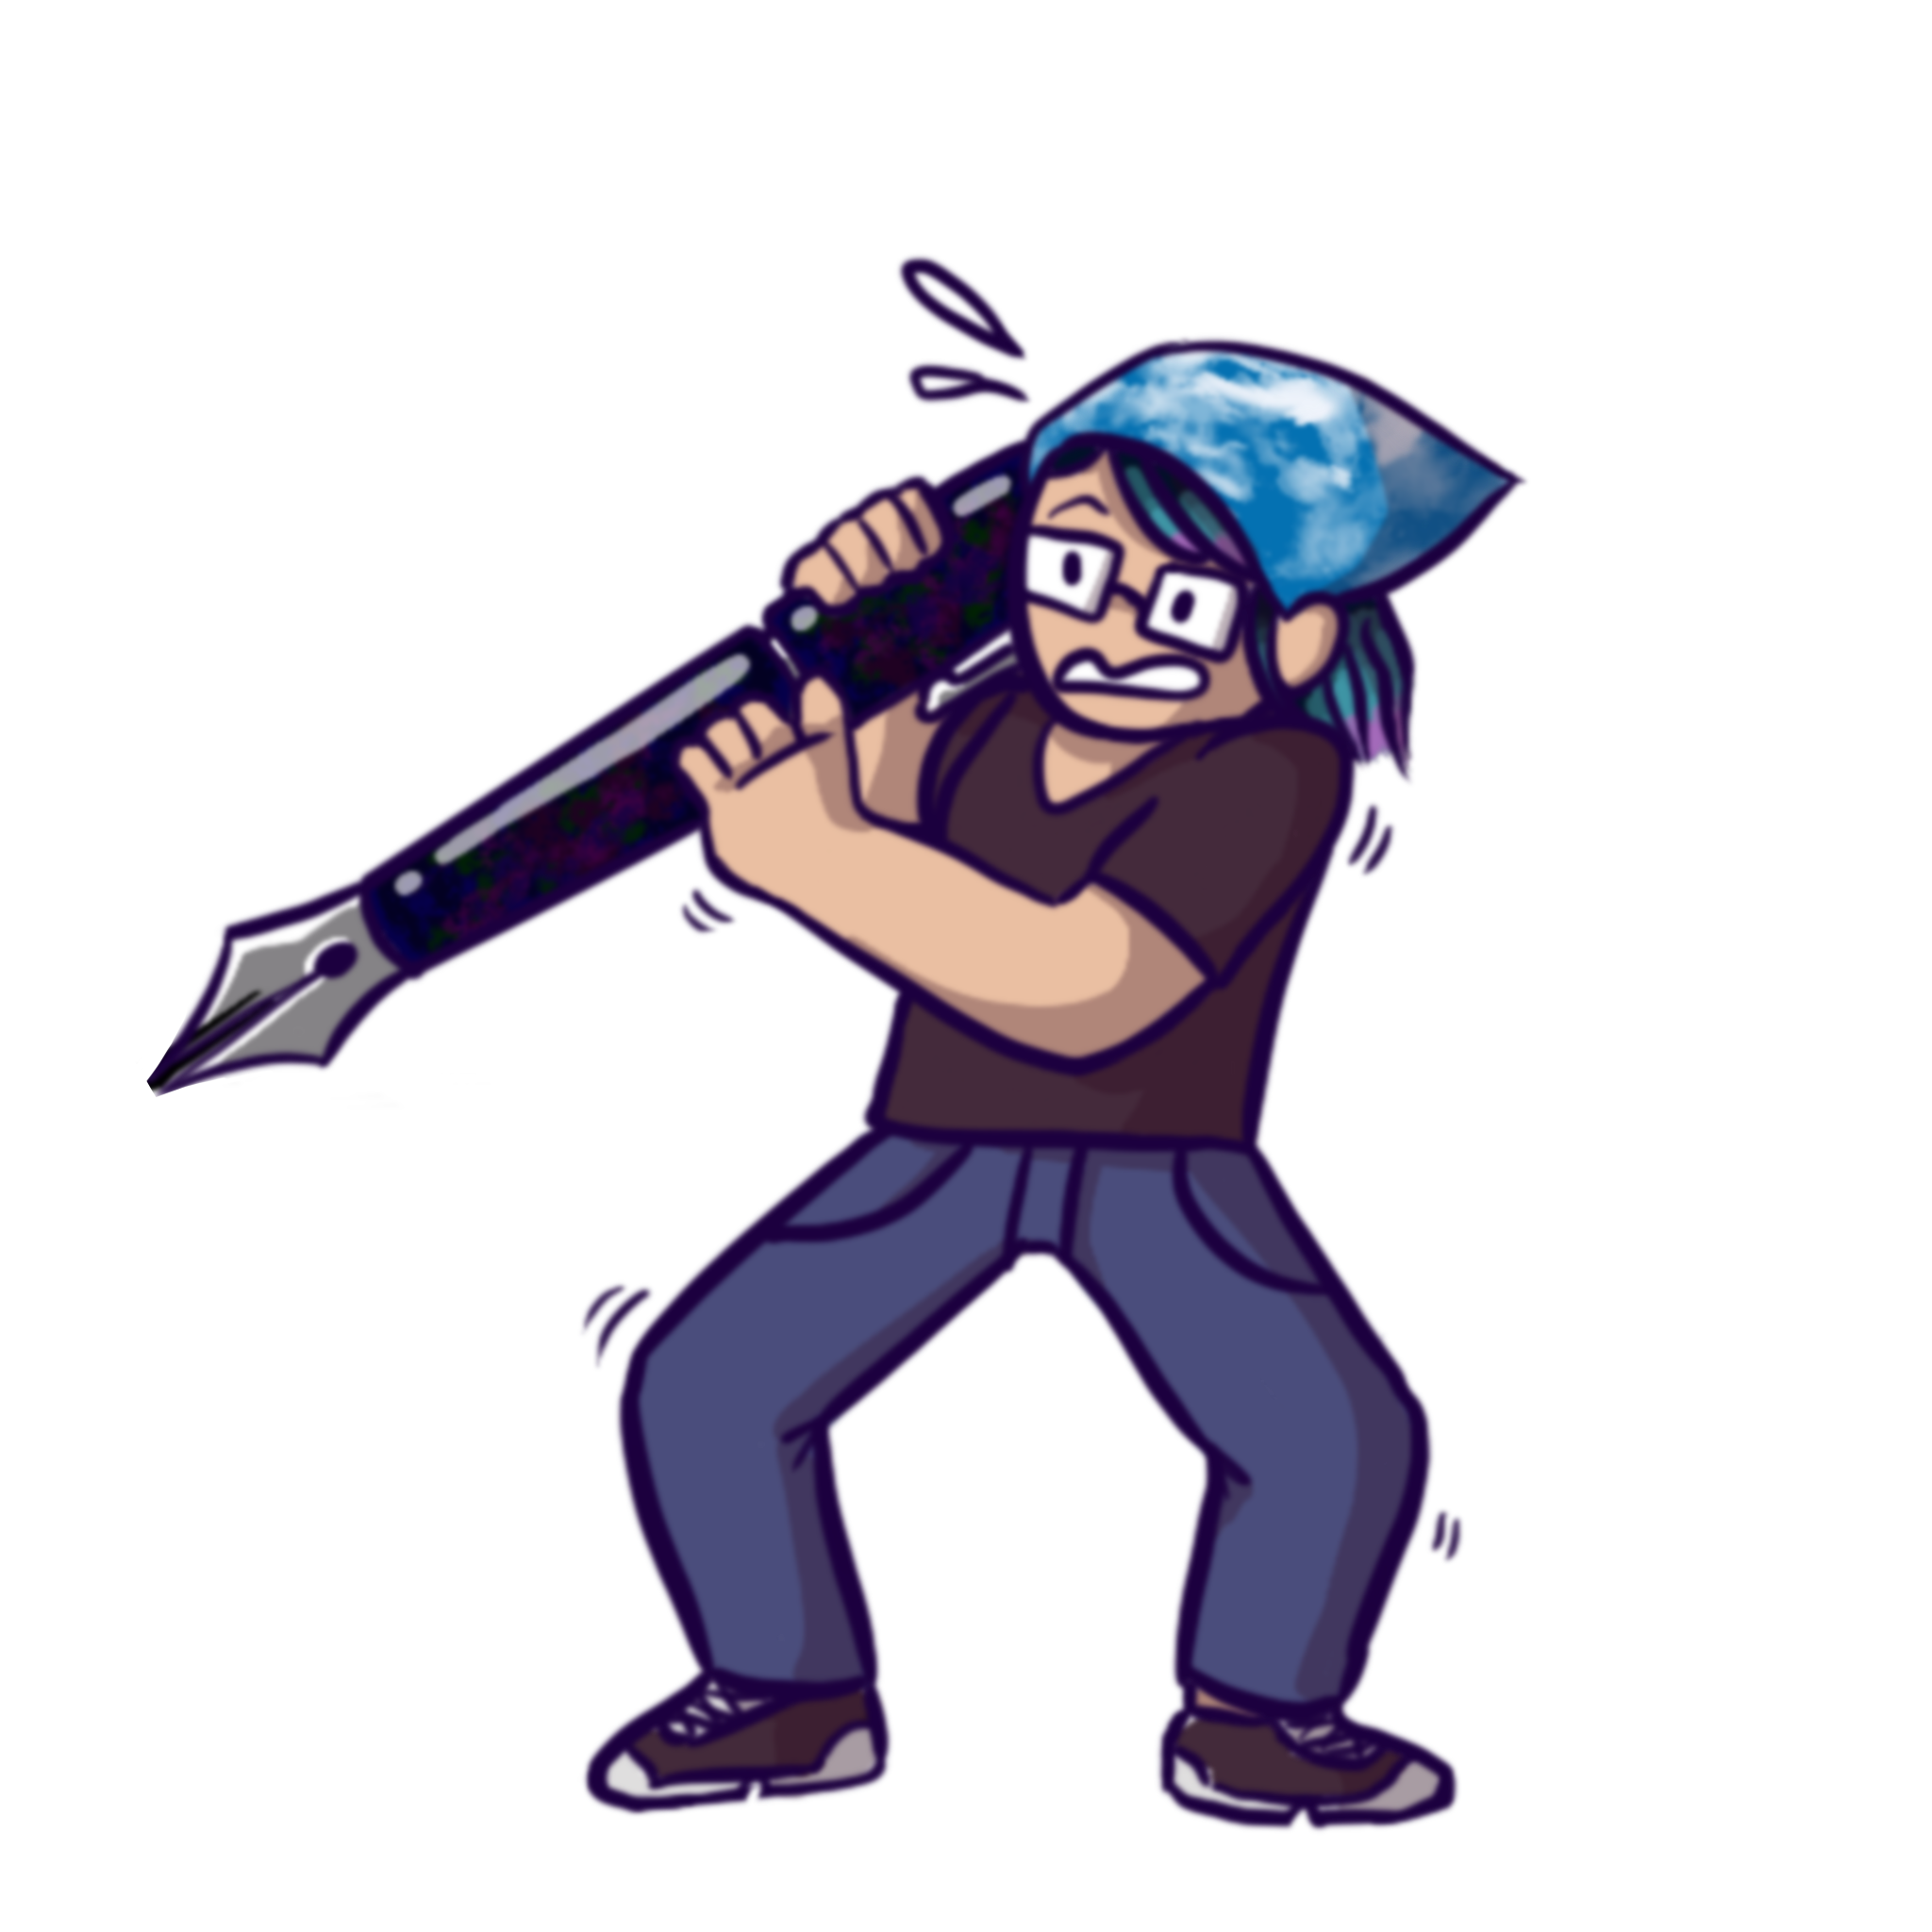

Mur Lafferty 00:00
Hello writers, fans of I Should Be Writing, or people who stumbled in thinking that this was a recent podcast. Actually, it is a recent podcast. It's a recent throwback podcast. This is I Should Have Been Writing. I am Mur Lafferty and this podcast is to take my work my podcast from 18 years ago, back in 2005, and see what I've learned. See what I've learned, s ee what I was wrong about. I had not published anything at this point, except for some role playing game work. No short stories, no novels, novellas. Podcasting was barely a year old. And I decided to start chronicling my writing career. And so I did that. And I'm still doing it, but I decided to go back and revisit them. So now we're on episode three.

Mur Lafferty 00:54
And if you don't, for some reason, you don't listen to I Should Be Writing, let me do a little bit of backstory. I have been diagnosed with ADHD. I don't think I was-- no I wasn't diagnosed when I was podcasting, this. I'd barely been diagnosed with depression. But when I was podcasting this, but consistency has been a problem with me. Even if I was able to record regularly because of Twitch, I was still having trouble getting it posted on a regular basis. And the third podcast is my very first time I'm like, 'Oh, crap, I didn't get this in on time. Sorry.'

Mur Lafferty 01:34
Yeah, that's gonna happen again. And I need to just deal with it and accept it and move on. Because I am a one woman shop occasionally I've had people helped me out on production. I'm not able to afford that right now. So I'm doing it all myself. And it's easy to record and harder to edit, and produce and upload and make the blog posts and make the blog post for Patreon and run the transcript and edit the transcript, all that stuff. It's just there's a lot of steps beyond just recording and that is where I slow down.

Mur Lafferty 02:09
But you know, we talk a little bit about Dragon Con little bit about, you know, how the podcast is going but, what we get into here is submission guidelines. And I'm pretty proud to say that not a lot has changed. I don't think I was pretty right at the time. So we're gonna go ahead and listen to that. And I'll see you on the other side, take it away Dana Countryman.

Mur Lafferty 02:56
Welcome to I Should Be Writing. This is your host Mur Lafferty. It is very late. In September 6, I should have had a podcast on Friday, but I was at Dragon Con. Sorry about that. But I was at Dragon Con, doing writerly things like getting an interview for you with Mike Stackpole to play next week. So I did pretty well with my challenged myself to write on my fiction every day, until Dragon Con came. And then it was even a stretch to write on my assigned words, much less my fiction words. And then when I got back, I had an email from an editor who had last week said, 'Hey, we want you to write this for us.' And I said, 'Cool. Hey, when's the deadline?' And then when I got back, I got the email of, 'Oh, didn't we tell you? It's Friday. So I have a 29,000 word project due Friday, and a 2000-something word project, but requires a lot of research due Friday.'

Mur Lafferty 03:59
And I'm going a little insane because I usually like to have at least one day after a trip to decompress. And my body kind of forced me to take that yest-today. Regardless of how much work I did, I did about 2000 words on the 29,000 word project. And I've done a little bit of research on the other one, but not really looking forward to this week. I'm looking forward to Sunday,

Mur Lafferty 04:24
I got invited by some of my gaming buddies to write on a print on demand, slash PDF, gaming or fiction collaboration to benefit the victims of Hurricane Katrina. And I'm really excited about that. However, the deadline for that is next week, so I'll have pretty much Sunday through Thursday to deal with that. I'm really looking forward to the 16th I think on the 16th I'm going to drink a big beer. I'm going to go to the fancy wine shop that sells all the good beer as well as the wine. Yeah, I'm going to buy myself a big beer and I'm going to Drink it on the 16th? Because I think I need it.

Mur Lafferty 05:02
But yeah, I don't even know what my word count is. It's whatever. Let me check, hang on. It's something above 65,466 words. I know it's above that because I got a little bit done at the con. But I haven't done a full word count yet. I guess this does prove that sometimes life does hit you on the head enough to where you can't concentrate on writing. So I'm a hypocrite. I do encourage you to try to write frequently. But let's put the let's put the daily thing on the back burner. Is it practical? Are you going to write on Christmas Day when you're with all your family, and you have no time to yourself? Don't know, if you're a professional, and you get paid for the fiction, that maybe you can say 'I'm sorry, I have a novel due to my agent,' that I have the writing voice down right there. But when you're just like us, it's hard.

Mur Lafferty 05:58
So I'm definitely going to, I don't know, I will work harder. Right now I have two deadlines, both writing. And that's a lot of words I got to do between now and Friday. And I don't know if I'm gonna get any novel words in, which breaks my heart. I got a rejection today. If you read the I should be writing blog, you'll have heard about this. But it was kind of funny. I got home from my trip and got no checks in the mail, which was depressing, but didn't get a rejection letter. Nice. It was a form rejection letter, which I'm used to. I don't have a problem with 'dear writer, you know, sorry to tell you but your story didn't work for us or doesn't fit our magazine or blah, blah, blah.' However, they didn't say what the story was. So I booted up my computer and I loaded up trusty sonar and I looked and apparently I hadn't logged what story I had sent in. So now I'm kind of at a loss because granted, I don't have like a ton of stories that are circulating the rejection circuit right now. But, you know, it'd be good to know, just so I don't submit it again. Like I said, I've everything that comes back rejected. I'm trunking right now, so I can focus a hundred percent of my novel. And as you just heard, I'm not focusing 100 present on my novel. I'm focusing like 5% on my novel. Oh, this is harder than I thought. But I'm going to stick with this podcast, even if I have to contradict myself dammit. So onward.

Mur Lafferty 07:41
Okay, where are I notes? That's right. Speaking of rejections, I wanted to talk about doing your market research, and you're studying the submission guidelines. Now, market research is actually something I need to work on because a lot of my stories do fall under as I mentioned before, the weird **** category. Actually, I mentioned this on the dragon page winging it podcast not here. But I feel silly saying that my stories are fantasy when there is not a lick of sword or sorcery in it. My stories entail things that could not happen. But for example, I have a story about Santa Claus and his elves, and how one elf is obsessed with Tom Petty. And this one elf gets mad about the fact that Santa gets all the credit while the elves do all the work. And so he rebels, and it's called "Merry Christmas from the Heartbreakers".

Mur Lafferty 08:34
Do you call that? Fantasy? I guess Santa Claus, fantasy, whatever. But anyway, it's very important to do your market research. You need to look at what magazines want, what just looking for the top five publishers, and then sending them stories is a waste of postage, and a hit on your ego honestly. Because, say analog is not going to want your story about these talking dog. Cemetery dance is not going to want your story about your space opera. You need to read about what people want. You need to follow whether they want hard sci fi, or just sci fi, or sword and sorcery or just any sort of weird crap.

Mur Lafferty 09:22
But it's important to read your market research. It's very important. Here's another thing, submission guidelines. I used to work at a computer gaming company. And I made friends with one of the testers one of the people who was in charge of making sure that the game worked. And when she would run a beta test, she would send out a notice saying, here's what you need to do to qualify for this beta test. And anybody who got one bit of those instructions incorrect, she threw them out. Didn't matter what sort of credentials they had didn't matter how many games they played before, or how many games they've tested before, she threw them out because the inability to follow instructions would not help her when she would be testing a game. So submission guidelines work kind of like that. If you submit your story on pink paper, with green text, you write a little story about how all your friends like your story, and how it's based on your dog that died when you were five, and your cover letter and your use size 10 font in I'm trying to think of a clever font name. None of them are coming to me. How about a non courier non Times New Roman font, something splashy something to catch the editor's eye, they're going to throw you out. That's it. That's, it's one easy thing they can do. to weed out the people they don't want is people who can't follow directions.

Mur Lafferty 11:05
Now, I know that it's hard. It's hard to write your story. But when you're done, you feel so damn good. And if you get your rewrites done now, we'll cover rewrites later in a later podcast. Get your rewrites done. And then you feel really good. And then you say, Damn, I am ready. Here I go. And you go and you find the first magazine you can find and you're so excited, you send it off. And you don't do any research. That is a waste of postage, a waste of your time, and a hit on your ego. You can write whatever you want. And be a writer, call yourself a writer. Go ahead, just do it. You got my permission.

Mur Lafferty 11:47
I went to a class with Orson Scott Card once and he said Why are you all here? Why aren't you home writing? If you came here to get justification that you're a writer fine. You're all writers go home.

Mur Lafferty 11:58
And yeah, you can be a writer. But if you want to be professional about it, you're going to have to do your market research, you're going to have to follow the instructions that the publication's put out, you can't prove yourself to be the next greatest brilliant fiction writer if you can't follow instructions. So that's my that's my rant, need to follow instructions. And in my next segment, you'll hear how to do market research. Because in these days with the entire web, it's very easy.

Mur Lafferty 12:44
Write this down, ralan.com r a l a n.com. Granted, again I'm sorry, if you're a non genre writer, you may not get all you want to get out of my podcasts. But seeing as I am a genre writer, you're going to I'm going to talk about genre stuff. Ralan talks about a couple of non genre things. But I have found this website to be the best collection of markets that there is. Do not go and this is my personal opinion. And I will give the usual caveat of I am not a published writer, but do not go to the Writers Market, the $50 fat book that's published every year. I made that mistake last year and I'm regretting it because they do not have three fourths of the markets that I want to I want to submit to and it was a waste of time, waste of money. Wasted time looking through it. I can find so many more markets online than in the Writers Market book. Granted, the Writers Market does have some good advice like Oh, follow submission guidelines. But overall, it was a waste of money.

Mur Lafferty 13:58
Go to ralan.com or in your own genre. You can search for just market listings, romance market listings, mystery market listings, whatever. Ralan does not have the best website design. Granted, I'm a web professional. Okay, in a former life, I was a web professional. And content design really speaks to me good content. Good content design is awesome. Bad content design makes me itch. Raelynn makes me itch. However, the content itself is so useful that I don't even notice the itch. Sometimes when I'm trying to puzzle out the difference between paying markets and professional markets, then I get a little headachy but overall, it's got really good information. It's got hundreds of listing, you can find whatever you want. Really, if you have a story about giant lizards rampaging across Tokyo, there's an anthology for that. I don't know if the writing period is close by now. It probably has been If you can find it on Raelynn you can find out who the editor is. So you will not write your cover letter to Dear sir, dear madam. Oh god do not write. Dear sir, if you don't know who it is because women editors get really pissed off at that. Boy howdy, and I don't blame them. When you're doing your submission guidelines. Also do your research on who the editor is of the publication you're writing for. Spell it right. And Ralan will give you all this information will give you the spelling and the name of the editor, it will give you whether the editor has changed because if you set up a database three years ago, you might want to check and make sure everything is the same, it will tell you how much the market pays, it will tell you whether they're inundated with slush and are not reading right now. If someone's not reading, then they will throw your manuscript away. And that is also a waste of postage. What I'm really trying to do is save you postage, that's really all it is. Okay, it's not really all it is.

Mur Lafferty 16:01
Did I mention it's late? I'm sorry. Raylan is just excellent for all sorts of information. And I highly recommend it, go there first. Even Even if you don't feel ready to submit something, you should go there and check it out to see what the process is going to be like what you're going to have to do what you're gonna have to think about, see what people are paying. If you think that you're going to make it rich writing fiction, well, you might want to need a little bit of cold water splashed on you in the form of rhineland.com. But it's a really excellent site. And every writer I know, that is still in the blind submission process, and is actually published something uses Ralan it's fantastic.

Mur Lafferty 16:58
Thanks for listening to I Should Be Writing. I really appreciate all of the feedback I've gotten in the past couple of weeks. It's been overwhelming, frankly, because I didn't think that anybody would want to hear about a writer who's unpublished and frustrated and take advice from her. But you do and I appreciate that. So next week, I'm changing the show format, I said I was going to do an interview every five podcasts. I'm changing that to every four podcasts because I sat down with Mike Stackpole at Dragon Con, and I got a really good interview with him. And I want to bring that to you as soon as possible. So we're going to be playing the Michael Stackpole interview next week. And then going back to our old format of three podcasts about me talking to you about my trials and tribulations and rejection slips. I need to sit down and count my rejection slips I'm up to not sure if I'm up to 30 yet, but I'm between 25 and 30. I know that.

Mur Lafferty 18:00
And in show five, we'll be talking about rewriting. See, I'm planning, aren't you impressed? Until then this is Mur. You can reach me at mightymur@gmail.com. The blog is at should write.blogspot.com. And you know you should be writing?

Mur Lafferty 19:01
What has changed? Not much, I'm still late. I still believe submission guidelines should be followed very closely. Actually, I'm an editor now. So I believe it even more. Believe it or not. There are reasons your editor has wanted submission guidelines the way they are and when you don't follow them. The first thing you're telling them is I don't respect you enough to follow your rules. People generally don't like to hear that.

Mur Lafferty 19:27
But yeah, this is I Should Have Been Writing. If you'd like to listen to my podcast and find out what I'm doing these days. You can check out murverse.com or you can subscribe to I should be writing or ditch diggers, which is the show about the business of writing that I do with my friend Matt Wallace. You can search for all those on your pod catcher or check out murverse.com

Mur Lafferty 19:49
The thing that allows me to run this transcription software and run my marketing software for Tiktok and Instagram. That all costs money and the people who support me via Patreon help pay for that if you feel the need to help out a creator patreon.com/mightymur you can support me you can get access to all my archives you don't have to wait for me to put them out once a week. And you get into a specific an exclusive, (not specific,) exclusive community and you get the news a little bit faster than everybody you get the updates a little bit, the new podcast earlier than everybody and you get sometimes you get extra stuff. And honestly, I will be doing extra content. And the more cons I go to now that the pandemic is less it's not over but it's it's a little bit more manageable. The more exclusive content I can get for you. But yeah, this is I should have been writing. I'll see you next time I believe the next time we talked to Michael A Stackpole for my very first interview for I should be writing. Looking forward to that. If you got any questions, email me mightymur@gmail.com And until then, you should be writing.

