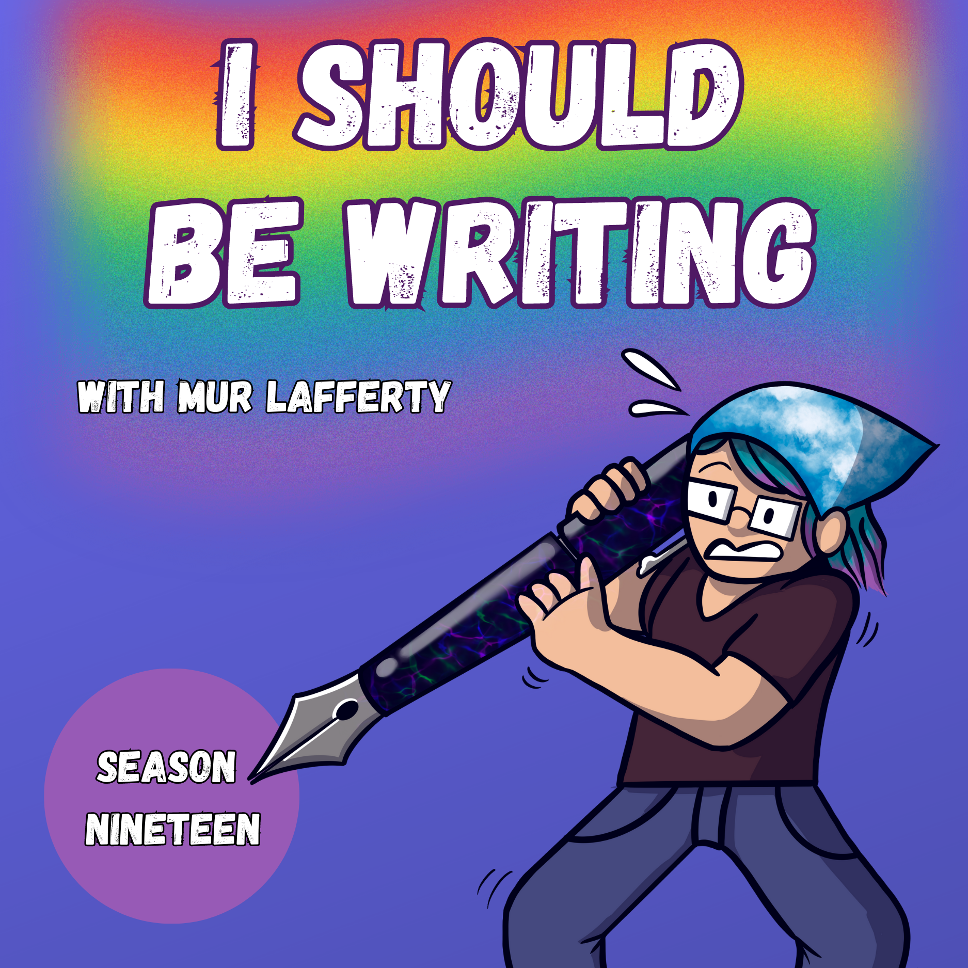
On the Importance of Fanfic (RIV Blaseball)
I Should Be Writing S19 Ep24
SUMMARY KEYWORDS
douglas adams, blaseball, adhd, fanfic, brain
SPEAKERS
Mur Lafferty
Get the annotated transcript when you support via Patreon or Substack!
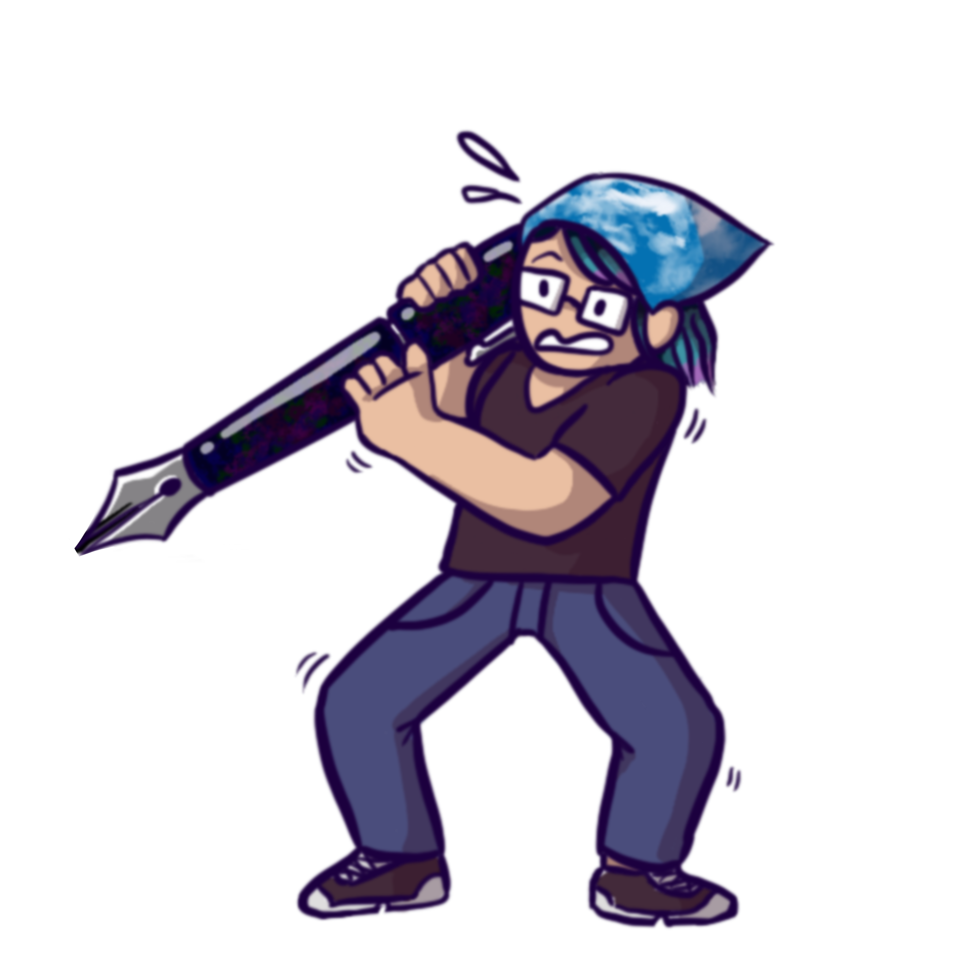

Mur Lafferty 00:00
I should be writing season 19 Episode 24

Mur Lafferty 00:30
[Theme music]

Mur Lafferty 00:36
hi there welcome to I should be writing. This is a podcast for want to be fiction writers and I am your host Mur Lafferty. I've been podcasting since '05. I've been writing traditionally published books since '11. And I've got my next book is coming out in November. So that's why I'm here. Why are you here?

Mur Lafferty 00:59
Hopefully you're here because you want to be a better writer, or you want to turn this into a business. What this podcast has done is chronicle my movement from having not sold any short stories to well, putting out my eighth book this November, I can't promise you, you'll get published. And I hate people who do. But I can promise you, you're not alone in any of your fears. Whatever you're afraid of, you're not alone. And the thing is about those fears, if everybody has them, no matter how successful you are, does it really have to do with writing? I don't know, I am not a mental health professional. I am not a professional writers coach. I'm just me.

Mur Lafferty 01:40
Little bit of announcements. If you haven't kept up with the feed, or you haven't, or this is your first time listening. As I said, I've been doing this since 2005, before I sold my very first short story. And I've decided to start releasing the old episodes with commentary. They will also be released with transcripts. And if you support at patreon.com/mightymur, you'll have comments in the transcripts. And those are fun. I'm trying to make them fun, they are fun to fun to do. The very first episode was put in the I should be writing feed, to subscribe to subsequent ones, you need to subscribe to the I should have been writing feed. And that'll be in the show notes or you can search for it. I spent a great deal of time putting all my podcasts into worldwide directories as best I could. But I think it's fun just to look back. And I'm trying to decide if it's a good thing or a bad thing that a lot of the stuff that I apologize for as a podcaster in 2005, I'm still doing in 2023. And at some point, I should probably just stop apologizing and just accept it.

Mur Lafferty 02:46
Consistency is hard for me. And you know, when I was doing the live show, I don't think people on the feed, listening to the podcast, appreciate it as much. But you gotta admit y'all, you got a lot more content. Because right now I don't have a set time for me to record our set time to upload. And I'm going to need to figure out how to do that. But I am an adult woman who was diagnosed with ADHD as an adult. And I'm doing the best I can. I was working with a professional content creator coach, and was talking about my organization and prioritizing problems. And he's like, 'What are you going to do to be accountable?' And I said, 'Well, it would help if you like, poked me once a week,' and said, Are you doing your thing? And he's like, 'No, I won't. Because I'm not a babysitter'. And my first thought was, that's fair. My second thought was, know what? it's unfair because of of a number of issues. First, the ADHD mind is weird. And I don't know if there's an ADHD thing, or just people who work from home thing. But when you create in a vacuum, you get the sense maybe that no one cares. That's why I liked doing it on Twitch so much, because they were people right there who cared the whole time. But this is, is anybody really gonna care that I didn't get to show up this week. I don't know. But if someone's poking me for accountability, that helps. Also the ADHD brain has trouble with time. And I figured this out last week when my iPad died, not died-died, just ran out of battery. And this is how I feel with time as well. So people don't understand why ADHD people are always late. Because we look at clock and see I've got five minutes left before I need to leave. And then suddenly we look back up and it's 15 minutes have passed and we're late. And I was looking at my iPad and said 4% battery, and I kept using it. Then it said 2% battery and I kept using it and then it died and surprised me. And I thought like 'you knew what the battery was at, didn't you?' and I realized what my brain was doing was, 'I don't need to do anything because I've still got 4% left. I don't need to hurry, because I've got five minutes before I need to leave.' Also I don't take into account the time it takes to park, walk inside an appointment building and get checked in. That's another thing. But it's like, when you tell me I've got a small percentage left, I'll think, Okay, well, I'm gonna use that small percentage, and then I'll act because yes, we understand that we have four minutes left, or 4% left, but there's no alarm in our heads going, that means 'you have to move.' Now, it's hard to explain this to people who don't experience it. It sounds stupid when I say it aloud, but it's how I've understood my brain to work. But that was a big, big tangent.

Mur Lafferty 05:46
But yeah, there's the old episodes going up. And I'm doing transcripts on the new episodes as well. Also transcripts, also annotated transcripts to the patreon patreon.com/mightymur. But for accountability, I finished up 10,000 words, almost exactly four chapters 10,000 words of a project, and I'm sending it to my agent to see what he thinks. I sold two projects on proposals on small proposals actually, like paragraphs. And you'd think that's, that's exciting, because you don't have to write the whole book, once you become established, and people know, you can start and finish a book and they can guess they'll probably like it, they'll buy a book based on a paragraph, the problem there is, you may not deliver the book that your paragraph created in their mind. And that sucks. So since I struggled with that a couple of years ago, and now I'm doing the I'm just gonna write a big ol hunk of words, send it to my agent, see what he thinks. And I'm still not talking about what I'm working on, which is exciting. And I don't know, it's bad, because I want that validation.

Mur Lafferty 06:53
But I realize if I get even a smidge of a negative comment, it's gonna crush me. It's not the time in the writing process that I need feedback. I'm not saying I don't take feedback. I'm not saying I'm a prima donna. I'm just saying that. When I'm in the process of making and I want to go, 'Oh, my God, this is really cool. Hey, friend, this is really cool, isn't it?' If I get anything less than 'Oh, yeah, that's awesome!' Then I'm going to start looking for the negative. And even if someone says, 'oh, yeah, that's awesome.' But they don't say it the right way. My brain is gonna go, 'ooh, why weren't they that excited? Are they excited as I was?' I remember sending the first couple of pages of a project to somebody. And I was so excited for her to see them. And she wrote back and told me, I use passive voice and the first paragraph, that shut me down. Yeah. So I just decided to avoid all that. I'm not, I'm not sharing anything with anybody. until I'm ready.

Mur Lafferty 07:47
I do want to start telling you guys what I'm reading, because there are so many good books out there. And you may not have heard of them. Currently, I'm reading The Other Side of Infinity by Joan Smith, her publicist has sent me a copy. And I really, really been enjoying it. They call it 'they both die at the end meets the butterfly effect.' It's got a boy who gets help saving somebody from drowning. But he gets all the attention. And the girl who helps him can basically see the entire future. And I really love stories about people in the future or little changes causing big ripple effects. And frankly, the whole Cassandra thing. So I'm very much getting into this. And it didn't want to talk about it is out by now. It is came out in April. So sort of speculative fiction, romance, why a and if you're into that, I think you'll be into this book, got magical gifts, a missing mom. And of course, secrets. It's been called philosophical, emotional, speculative and powerful. And it is so far. And yeah, I'm always looking for romance that kind of I love genre bending. I mean, that's really my thing. Which is, you know, why, right, mystery and science fiction blending together, sort of a real world magic teen romance. So yeah, that is the other side of infinity by Joan Smith. And I did receive this book for free for review. But I also bought it just so it would stay on my Kindle. And I wanted to support the author because it's really good.

Mur Lafferty 09:29
I was going to talk about ADHD and the brain. And I think the only thing I wanted to talk about, besides what I've already mentioned was, I mentioned that I sent my 10,000 words into my agent, but I wanted to talk about the ADHD brain. I think it's ADHD brain or maybe it's just my brain. But when I turned it in, you know, I've been working on this for months. i It doesn't take me, you know, several months to write 10,000 words, it took me several months to write these 10,000 words because I had several false starts where I wasn't sure of some things and I just needed to work it through. But I'm confident, I sent them in. And then when I did, it was like noon, maybe one o'clock. And I wanted to go, 'Okay, now I need to work on some podcast stuff'. And my brain is like, 'hey, we turned in a project, let's go on vacation!' And I'm like 'no brain, we still have things to do' and brain's like, 'Nope, I'm out of here.' And then there's just like static in my head.

Mur Lafferty 10:25
And whenever I finish a major project--and this wasn't even finishing, it was just coming to a nice milestone in the project--and sending it off for someone else to look at. But still brain said, finished. And I found it very difficult to focus on anything else that day. So I did errands. And I'm mentioning this to say that I know several people who, when they get to the end of a project, they are surprised at their negative feelings. Ursula Vernon always goes into a funk, when she's done with the project. There's no, you know, it might be for you, it might work for you. But for a lot of people, there's no big sense of satisfaction and completion. There's just, wow, I'm tired. And sometimes we think we're doing it wrong. If we're not having the expected experience, the experience of writers in movies which just like write the end, and then just look all satisfied and happy with themselves, instead of like unwashed with a headache that's just like on the horizon waiting to knock you over, or the middle of the night, or all three. But yeah, one thing that might happen is you get down. Another thing that might happen is you just turn off, your brain decides it's time for a break. And it's really hard to jumpstart that. So I've said you need to take a break when you get bad news or rejection, you also need to take a break when you finish something because your brain deserves that break.

Mur Lafferty 11:49
Other stuff going on, I got the new Matt Wallace book, savage crowns, the final part of his trilogy. And that's coming out next week, I believe. And we're gonna do a live ditch diggers on Twitch twitch.tv/mightymur to talk about the new book and writing a trilogy and stuff like that. Couple of disappointing things, she podcasts [Live!] was cancelled slash went virtual. And that kind of upset me, because we were, it was first scheduled for [last] October, and I was invited to be a guest of honor. But then they too many people got COVID on the team, and they had to reschedule for June, which you know, was sad. But okay, I accepted it. And I was looking forward to going to an in person podcasting event to talk to other people to see what technologies people were working on. And, you know, just to network to go to DC to see some friends I only know online, I was really looking forward to all that. And then recently, they cancelled it and went virtual. And what emotion I did not say how I having was excitement about my actual presentation. I was quite nervous about it. Now it's impossible to have a creative career. That's not that doesn't include stuff like marketing stuff like promotion, stuff like social media. And if all you want to do is create well, you really can't do that anymore unless you've got a team around you. And in the first couple of years of podcasting, those of us in the nerd circles, we built a pretty tight group, and what helped promote each other would help do collaborate with each other. And then we kind of all went our separate ways. Tee Morris is doing a lot of stuff on Twitch now. Scott Sigler is doing a lot of live streaming. And I think he's writing YA. I know he wrote some way I don't know what he's running right now. Christiana Ellis has moved to Twitch. She does a lot of role playing games, like tabletop role playing games, and with her are Paul Fischer and nobilis and Starla Hutchton. And Jenny beanses I believe, and those are just the ones that pop into my head. And I'm still in touch with some of these people, but we don't get together and make stuff together anymore. And the reason why I'm bringing this up is because I have been kind of head down creating in the podcast world for over 10 years. I've been writing, developing my writing career, but also I'm just making the stuff and putting it out. So when they invited me to do a presentation, I thought, What the hell do I have to talk about? Because I I don't know what to say in the realm of podcasting at large. Yes, I was one of the first Yes, I'm in the hall of fame but I don't really have a community of podcasters anymore and I don't know what's going on in the larger space except that it's huge, yay. And except that a lot more people get paid for it. Now I think companies just hire people to make podcasts for them, which is great. I imagine you can use a lot, put a lot more, put a lot more time into it, then what it feels like it's moved on. And I'm just still here, doing my thing. And that could be a reason why I'm not growing. But because of all of these things, I didn't feel like I had a whole lot to talk about. And I was really nervous. And when they went virtual, I thought

Mur Lafferty 15:31
I was looking forward to the Con and the trip and being able to see some people, both in podcasting and outside of podcasting. But now it would just be doing a talk that I was very nervous about, with none of those bonuses, and I hate hate online conventions. I think they're great. I think they're awesome, especially if you've got people who don't have the ability, or the finances or, or in the area to go to a regular convention. I think adding virtual stuff to your convention is brilliant and needs to stay around. But I don't like doing them. For some reason, I find it easier to get in front of people and do a panel in real life than it is to put my game face on at home and do it. And it feels different from podcasting. It feels different from streaming, I don't know what it is, but I really dislike it. And I remember hearing people talk about--usually comedians--and they talk about how hard the pandemic was, even if they pivoted to [performing] online because they couldn't get anything from the audience. You don't know what jokes land, you don't know what jokes jokes hit, and you can't have it and figure out what to do for the audience. after that. I know David Sedaris wrote some had a book release, I think, I don't know if his his books are just a couple of essays. But people didn't like them. And he said, You know, I, I tour with these essays, and I find out from the audience which ones work and which ones don't. And I didn't have that this time. And being on a panel is one thing, but doing like an hour talk is just terrifying to me. So I told them, I couldn't do it. Because I was willing to put forth all the stress and anxiety to make my presentation. Because I would enjoy the con as a whole apart from that. And I wasn't getting any of that. And it was just causing me more stress. And I feel bad. Because you know, even as the whole world going 'Do self care, tell someone No, be nice to yourself!' there's still that feeling of letting somebody down. And I know it's not easy for them to have made this tried to make this convention at a time when everybody is scrambling for money. But at the hotels got hit big hard (big hard?? My God) the hotels got hit pretty hard with COVID because people weren't traveling. And so if you had an event, they weren't, you know, they were not letting go of deposits for events very easily because they were losing money. And so the people who made ran the events lost money. But I had to do it for my mental health.

Mur Lafferty 18:24
And the other thin--And this had nothing to do with writing--No, actually it does! It has something to do with writing. The other thing is, blaseball got canceled. And blaseball was a horror baseball sim that I was very, very into. They built a browser game that took off unexpectedly during COVID. It was like a game they were trying to make while they were making other games. But this one hit and it hit big and a hit hard. And on their end, it was so much work to keep it going. It was so much that working lots and lots and lots of hours because it was a real life sim. And they took time off. And then they came back and then they took some more time off and they came back and then took a lengthy time off. And then they came back and then took a year off and then they came back. And the last time they came back was in winter this past winter. And people were not entirely thrilled because from our point of view, from the gamers point of view, it didn't look like much changed. And granted, I know how-my husband's a software engineer- I know how much work you do, you can do on the back end just to make your life the coder's life better to make the game run smoother, so you're not having to slap band aids on it over and over again. But they did work for a year and we didn't see very much change at all. And so in some of the things were broken and they said okay, well-- they did two seasons and then they said 'okay, it's time to--we'll go on another siesta (as they call it) and we'll come back then spring.' They were giving us weekly updates on the things they changed things they improved. And then the last weekly update last Friday was, 'yep, we can't do it. It's not feasible. And the--like people got laid off. And another some unhappy fans. Fans of anything can tend to be entitled, but it feels like computer gaming fans feel like some of the most entitled--except for Star Wars fans. But computer game fans are very entitled because they think what you had worked, so why can't we just go back to that when, like I said, what what they had didn't work, they were not having quality of life, keeping that site together. And so I understand that it failed. And, you know, tell myself, it's just a game and you haven't really played it in over a year. But the thing is that while we were waiting for the game to come back, communities were built, people did fanfiction, people did fan art, the garages did fan music, which were was awesome. And now that blaseball is officially over, and their Discord is officially shutting down. And they're not putting out any more official content. It just makes me really sad. Because, yeah, people can still make content, and I'm actually thinking about it. But there's no denying that the community of fans and creators will fracture. And that just makes me very, very sad. Blaseball was another one of those things that made the pandemic feel not so lonely. And I wasn't even hanging out in the discord spaces. My kid did. But I felt a little too old, let's just be honest, felt a little too 'Hello fellow kids' kind of thing. But when I talked to other people about blaseball, it was special. It was this very weird thing that we all had in common. Rest in violence blaseball, We'll miss you. Actually, I think what blaseball did was it let a lot of people know they could create. There's something about fanfiction that's beautiful, because a lot of people who don't have the confidence to write their own individual stories. They think 'Well, I mean, I could write the story about what I wished it happened in the Twilight world. And they'll write it and post it and get fans and followers and understand, 'oh, this is something maybe I could do.' As a professional writer, I have to say, using somebody else's copyrighted work is a copyright violation. But when it comes to fanfic, a lot of people just look the other way. Because there's there's amazing communities being built around fanfic, and fan art and all of that. And I think a lot of people, especially younger people, especially younger, queer people, got the confidence to make stuff because blaseball was so weird. If you tried to make something and it failed, you could just say, 'Well, you know, that's blaseball'. And I hope that the people who use blaseball as a place to start making neat stuff, keep making stuff,

Mur Lafferty 23:06
The problem with doing the show for 18 plus year is I forget what stories I've told. But then again, you may not have heard of it even if I have told it. So back in the late 90s. My husband and I went to the Electronic Entertainment Expo (E3), which I don't think is around anymore. But it used to be big, big computer game Expo to show off games that are coming, etc. And we both worked in computer game industry. And so we went to Atlanta for E3 and Douglas Adams was there. Douglas Adams is best known as the writer of Hitchhiker's Guide to the Galaxy, but he did a lot of other stuff too. He had a fascination with computer games. Note that fans will note that Dirk Gently's Holistic Detective Agency had

Mur Lafferty 23:53
the protagonist (beyond Dirk Gently) was a computer game designer, or software engineer. But he had a fascination with technology. And he wrote a book called starship Titanic and then they put out a game called starship Titanic. So my very long way of saying Douglas Adams was at E3. And my husband and I --it was like the last day and we walked by and we saw the starship Titanic booth and Douglas Adams was there. And we were both just like, 'Oh, my God is Douglas Adams, look it's Douglas Adams! Aaaa!" And we were all very shy and skittered away, then, you know, walked about 100 feet or so. And then we thought, 'wait a minute, will we ever get a chance to meet Douglas Adams again?' and we went back, brave and we put the shyness aside and we went back and he had already left for the airport. And it was great. The woman who was still at the booth felt terrible for us, that that we'd missed him. And she like gave us lots of swag, which was nice. I still would have rather met Douglas Adams because he died in 2001- In May 2001, actually. So he's been gone for 22 years? Wow, the thing is, usually when it comes to me being shy or not willing to take an opportunity, my husband says, 'Look, just remember Douglas Adams, you don't want that to happen again,' until it becomes our Douglas Adams moment. And I've kind of branched out and started making that be. Never I'm scared to do anything, not just meet someone. But one of the good and bad things about building a creative career is when you want to try something new. You think about it, on the terms level in the complexities of the other stuff, you do something new, that may not be the best idea. That's why I have not successfully written interactive fiction because I think in the terms of novels, the scope of my ideas is big-when I think I can write a novel, I think, 'All right, let's go.' And when I think I can write a massive interactive fiction, I think, 'Oh, God, where do I go? How do I do this?' And I did that with blaseball.

Mur Lafferty 26:06
There was a guy who started a, the first person to do live stream for blaseball, for told us his name, his name means he just called himself radio host. And he would stream all 10 games that were running at a time, like a second, third and fourth seasons. And third, four seasons were like the second, third and fourth weeks, the blaseball was a thing. by surprise, he burned out pretty fast trying to call 10 games at a time for a couple of hours. And I still miss him. Possibly, also, because, you know, I never got to know his name. So I don't see him on any other online space at all. But I Liked his, voice I liked what he made. And I was just starting to stream at that point. Then there was my friend, Joey T Badger, who did play by plays of the flowers games, because he was a Boston flowers fan. And I thought, I want to make something I want to make a live stream or a podcast or something for blaseball I want to do and I'm gonna do it. And all the ideas I had were too big. And I couldn't settle on anything. I couldn't get confidence in anything. And now blaseball is over. And I still haven't done it. Got that Douglas Adams feeling again? Why don't I take advantage of it? Why didn't I do the cool thing when I could.

Mur Lafferty 27:25
When you make something and people don't like it, that's the worst thing that's going to happen. They're not going to like it, they might tell you might hurt your feelings. But then you'll make something else. And here's a hint, if you don't have anybody who dislikes the art you make, you need to go wider. You need to get more people to pay attention to you. Because if everybody likes your stuff, you're simply not reaching enough. Because everybody has people that don't like their stuff. The bigger you are, the more people you have the don't like your stuff. It's a bell curve. And if you're missing one half of the bell curve, you need to work harder. If everybody thinks you're a three star writer, that's, it's boring. But if this person hates that story you told but this person's life was changed because of that story you told, and it could be the same story, then you're onto something.

Mur Lafferty 28:16
We celebrate rejections in the I should be writing community. And we don't talk about this very much. But I think we should celebrate one star reviews too. Because you at least stirred an emotion in somebody and you want an emotion better than 'meh'. It's hard to hear the negative reviews. And you know, if you're me, you try to avoid them. But you know, they're there. You know, somebody doesn't like your stuff.

Mur Lafferty 28:43
And I was going to talk about ADHD and the brain. But I think I've covered at the beginning. And really, so many times I've told you, which is really telling myself that the only one standing in your way of making something is you. And y'all know I'm talking to myself. So let's stop getting in our own way. Let's make bad stuff.

Mur Lafferty 29:04
I do not have an interview this week, alas. I believe my next interview will be James Sutter, former role playing game designer now a YA romance writer, and I'm lookin g forward to talking to him. I need to get better at talking about the books that come in because James's book is one of them. Oh, it's Darkhearts. And it's out today, June 6. So yeah. I'll be talking to him soon. Looking forward to that. And next week, we're launching Matt's book, savage crowns on twitch.tv/mightymur. So if you want to get in touch with me and you've got questions about writing, let me know mightymur@gmail.com the blog and shownotes are murverse.com. But I've just spent many hours submitting all of my podcasts to all every single directory I could find around the world. So hopefully, your directory will have my podcast if this is the first time hearing me. couldn't figure out how to put it on the the Japanese one though, gotta look into that. But my other podcast is ditch diggers, which I do with Matt Wallace. And I now have I should have been writing if you want to listen from the beginning with commentary, check that out it's reverse.com and are searched for I should have been writing on your favorite podcatcher because it should be there. Thank you for listening. Tell a friend about I should be writing support the Patreon at patreon.com/mightymur or check out my books Those are always both monetary and non that you can support me and the work I do. My most recent book is station eternity which is book one of the mid solar murders with Book Two of the midsummer murders coming out this November. Thank you for listening. Thank you for your support. And I'll see you next time until then you should be writing.

